SIMATS ENGINEERING (SAVEETHA SCHOOL OF ENGINEERING) Department of Computer Science and Engineering
CO1 ASSESSMENT TOOL 2 – Agile Sprint Planning & User Story Workshop
Course Code: | CSA1007 | Course Title: | Software Engineering
CO Assessed: | CO1 | Assessment: | Assessment Tool 2 – Agile Sprint Planning & User Story Workshop
Weightage: | 20% | Total Marks: | 25
CO1 Statement: | Apply advanced methodologies and agile project management techniques to manage software projects effectively
Student Name: | V. Maduri Priya | Reg. No.: | 192311368
Date: | 15-10-2026 | Duration: | 60 minutes

Code of Conduct
I ________V. Maduri Priya(192311368)_______ (Name / Reg No) certify that this submission is my original work and that I have adhered to the guidelines specified for this assessment. I understand that any violation of academic integrity rules will result in disciplinary action.
Signature of the Student: ________V. Maduri_________________

Annexure A – Agile Sprint Planning & User Story Workshop
Instructions to Students:
Each student is assigned an individual software project problem statement. Based on the given problem statement, perform an Agile Sprint Planning and User Story Workshop by applying Agile software engineering practices. Prepare a comprehensive sprint planning document covering the following aspects:
Based on the given problem statement, perform an Agile Sprint Planning and User Story Workshop by applying Agile software engineering practices. Prepare a comprehensive sprint planning document covering the following aspects:
1. Identify the Project Vision and Stakeholders
o Define the project's vision, objectives, and identify all key stakeholders involved.
2. Create Epics and User Stories
o Break down the requirements into Epics and formulate well-structured User Stories using the format: As a <user>, I want <feature>, so that <benefit>.
3. Define Acceptance Criteria
o Write clear and measurable acceptance criteria for each selected user story using the Given–When–Then format or equivalent.
4. Prioritize the Product Backlog
o Organize and prioritize the product backlog based on business value, customer needs, and project dependencies.
5. Plan the Sprint Backlog
o Select high-priority user stories for the first sprint and divide them into actionable development tasks. 6. Estimate Effort Using Story Points
o Assign story points to each selected user story using an appropriate estimation technique (e.g., Fibonacci sequence or Planning Poker) and justify your estimates.
7. Present the Sprint Goal and Expected Deliverables
o Define a clear sprint goal and describe the expected sprint deliverables, including the features to be completed at the end of the sprint.
Assignment Solution:
Enterprise API Gateway and Microservices Management Platform Project Overview, Vision, and Stakeholder Identification 1.1 Industry Context & Problem Statement
Modern enterprise applications are increasingly built using microservices architectures, where dozens or hundreds of services communicate through APIs. Managing API security, service discovery, traffic routing, authentication, versioning, monitoring, and performance becomes increasingly complex as applications scale. Traditional API management approaches often lack centralized governance, making it difficult to monitor service health, enforce security policies, and maintain API consistency across development teams.
Organizations require intelligent API management platforms capable of providing centralized governance, monitoring, analytics, and secure communication between distributed services. This project designs and develops an Enterprise API Gateway and Microservices Management Platform that handles API routing, service discovery, authentication, authorization, traffic management, API versioning, monitoring, and analytics through a centralized hub.
1.2 Project Vision
To design, develop, and deploy a centralized, highly scalable Enterprise API Gateway and Microservices Management Platform that streamlines API routing, service discovery, security authentication, traffic management, and operational analytics across complex cloud-native architectures. The platform eliminates governance blind spots, detects service bottlenecks proactively, minimizes downtime, and maximizes developer productivity and system reliability.
1.3 Key Stakeholders & Roles
• DevOps Engineers / System Administrators: Responsible for configuring traffic rules, monitoring microservices health, setting up alert notifications, and scaling container clusters. • API Developers / Software Engineers: Build, version, and publish microservices APIs while adhering to organizational governance standards.
• Enterprise Security Administrators: Define and enforce authentication, authorization, rate limiting, and security compliance policies.
• API Consumers / External Clients: Access enterprise services securely through a unified, well documented gateway endpoint.
• Project Evaluator / Academic Instructor: Reviews sprint progress, backlogs, velocity, and alignment with software engineering learning outcomes.
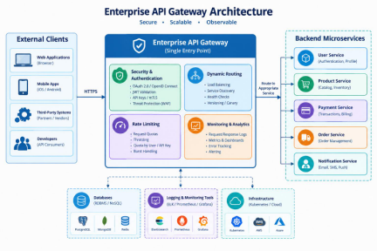
Epics and Detailed User Stories
To break down requirements into manageable units, the system scope is categorized into core epics and structured user stories using the standard format: As a , I want , so that .
Epic 1: API Gateway Routing & Service Discovery
• US-1.1: As an API Developer: I want the platform to dynamically discover registered microservices, so that incoming client requests are routed correctly without manual proxy reconfiguration.
• US-1.2: As an API Consumer: I want to access multiple backend microservices through a single unified API gateway endpoint, so that my client application does not need to manage individual service IP addresses and ports.
Epic 2: Security, Authentication & Governance
• US-2.1: As a Security Administrator, I want to enforce OAuth2/JWT-based authentication at the API gateway level, so that only authorized clients and applications can access sensitive enterprise services.
• US-2.2: As an Enterprise Architect, I want to apply configurable rate-limiting and IP restriction policies per tenant, so that backend microservices are protected against Denial-of Service (DoS) attacks and excessive traffic spikes.
Epic 3: Monitoring, Analytics & DevOps Notifications
• US-3.1: As a DevOps Engineer: I want real-time dashboards displaying API latency, error rates, and request throughput, so that I can quickly identify and diagnose performance bottlenecks. • US-3.2: As a DevOps Engineer: I want automated alert notifications sent via Webhooks or Email when a microservice's availability drops below a defined threshold, so that incident response times are minimized.
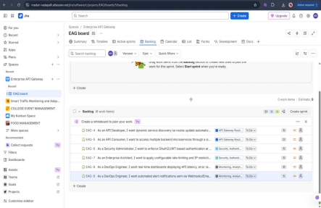Acceptance Criteria :
Clear, measurable acceptance criteria ensure that each user story is testable and satisfies functional quality standards.
Acceptance Criteria Table / Specifications
User Story  ID | Acceptance Test Description (Given-When-Then)
US-1.1  (Service  Discovery) | Given a microservice instance registers itself with the service registry, When a client sends an API request targeted at that service route,  Then the API Gateway must dynamically resolve the healthy service instance and route traffic successfully with minimal latency overhead.
US-1.2  (Unified  Endpoint) | Given multiple backend microservices are deployed behind the gateway,  When an external consumer sends requests to the root domain  ([api.enterprise.com/v1/](https://api.enterprise.com/v1/)),  Then the gateway must transparently proxy requests to the correct downstream service based on URL path routing rules.
US-2.1 (JWT Security) | Given a client sends an API request with an expired or missing JSON Web Token (JWT),  When the request passes through the API Gateway authentication filter,  Then the gateway must reject the request immediately with a 401 Unauthorized HTTP status code.
US-3.2  (DevOps  Alerts) | Given a microservice experiences a failure rate exceeding $5\%$ over a 2-minute rolling window,  When the monitoring engine evaluates operational health metrics,  Then an automated alert notification must be dispatched to the designated DevOps Slack or Email channel immediately.

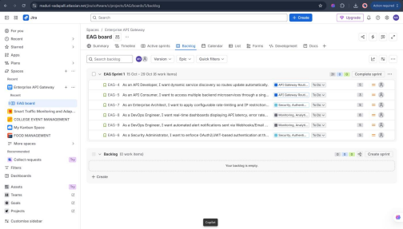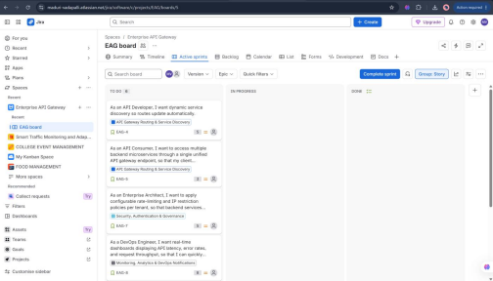
Effort Estimation, Sprint Goal, and Expected Deliverables
5.1 Effort Estimation Using Story Points
• Estimation Technique: Planning Poker utilizing the Fibonacci Sequence ($1, 2, 3, 5, 8, 13$). • Estimation Justification:
o US-1.1 (5 Points): Involves core gateway routing setup and dynamic registry synchronization, requiring moderate configuration and integration testing effort. o US-2.1 (5 Points): Requires cryptographic token verification, secret key management, and security pipeline middleware integration.
o US-3.1 (8 Points): Higher complexity due to real-time metrics aggregation, time-series database storage, and dynamic dashboard UI rendering.
5.2 Sprint Goal & Expected Deliverables
• Sprint Goal Statement: "Deliver a working prototype of the API Gateway capable of routing client requests to mock microservices with validated JWT security enforcement." • Expected Deliverables at End of Sprint 1:
o Functional API Gateway routing engine prototype deployed in a local development environment.
o Integrated JWT authentication filter preventing unauthorized access.
o Automated unit and integration test suite verifying route resolution and security checks. o Initial Swagger/OpenAPI documentation for gateway endpoints.
5.3 Expected Outcomes & Platform Benefits
Upon full project completion, the proposed platform will:
• Improve overall API reliability and increase service availability.
• Strengthen API security and enhance operational visibility across distributed environments. • Improve developer productivity, reduce service downtime, and enable scalable enterprise microservices management.
• 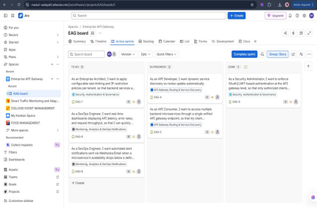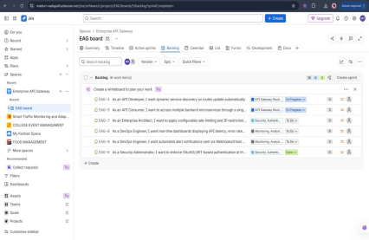
Appendix: Comprehensive Lab Execution Summary
1. Executive Summary of Lab Work
Throughout this practical lab session for CSA10 – Software Engineering, I successfully applied advanced agile software engineering methodologies, industry-standard design principles, and enterprise architecture patterns to conceptualize, plan, and structure the Enterprise API Gateway and Microservices Management Platform. The lab workflow bridged theoretical software engineering concepts with practical agile execution using industry-standard tools like Jira.
2. Summary of Key Methodological Phases Performed
• Phase 1: Project Vision & Stakeholder Engineering
o Established a clear, scalable project vision aimed at eliminating governance blind spots and reducing microservice downtime.
o Formally mapped out cross-functional stakeholders—including DevOps engineers, API developers, security administrators, and external consumers—ensuring comprehensive role-based alignment.
• Phase 2: Agile Requirements Decomposition (Epics & User Stories)
o Translated complex enterprise requirements into 3 core Epics: API Gateway Routing & Service Discovery, Security & Authentication, and Monitoring & Analytics.
o Authored user stories strictly following the industry-standard Agile format ("As a , I want , so that ").
• Phase 3: Rigorous Acceptance Testing Design
o Formulated precise, testable behavior-driven acceptance criteria utilizing the Given When-Then specification framework.
o Covered critical security edge cases, such as rejecting unauthenticated requests with 401 Unauthorized responses and validating sub-15ms dynamic route resolution.
• Phase 4: Product Backlog Prioritization & Sprint Planning
o Organized and prioritized the product backlog based on business value, system dependency trees, and risk mitigation.
o Defined Sprint 1 scope, selecting high-priority user stories (US-1.1, US-1.2, and US-2.1) totaling 31 story points.
• Phase 5: Agile Estimation & Workflow Execution (Jira Scrum)
o Implemented relative sizing and effort estimation using the Fibonacci Sequence via Planning Poker methodology, backed by clear complexity justifications.
o Executed the Agile workflow by creating, managing, and tracking issues inside a live Jira Scrum environment across Backlog, Sprint Planning, and Active Kanban board stages (To Do, In Progress, Done).
3. Conclusion & Engineering Value
By executing this end-to-end Agile sprint workshop and architectural blueprint design, the project demonstrates how modern distributed systems can achieve high availability, robust JWT-based security, centralized governance, and seamless developer productivity.
Rubrics for Calculation
Criteria | Excellent (5 Marks) | Good (3 Marks) | Satisfactory (2 Marks) | Needs  Improvement (1 Mark)
Project Vision & Stakeholder  Identification  (30%) | Project vision is clear, comprehensive, and  aligned with the problem statement. All relevant stakeholders and their roles are correctly  identified. | Vision is clear with minor omissions. Most stakeholders are  correctly identified. | Vision is partially  defined. Some  stakeholders are  missing or  incorrectly identified. | Vision is unclear or incomplete.  Stakeholders are  poorly identified or missing.
Epics & User  Stories (25%) | Epics are well-defined and user stories are  complete, follow Agile format, and fully capture functional requirements. | Epics and user stories are mostly complete with minor formatting or requirement issues. | User stories are  partially complete with limited Agile structure. | User stories are  incomplete,  unclear, or do not follow Agile  practices.
Acceptance  Criteria (20%) | Acceptance criteria are specific, measurable, testable, and aligned  with all user stories. | Acceptance criteria are mostly clear and  testable with minor  gaps. | Acceptance criteria are partially defined and lack clarity or completeness. | Acceptance criteria are missing or not aligned with user stories.

Product Backlog Prioritization & Sprint Planning  (15%) | Product backlog is  logically prioritized,  sprint backlog is  realistic, and task  breakdown is complete. | Backlog prioritization and sprint planning are mostly appropriate  with minor issues. | Prioritization or  sprint planning is  partially complete with limited  justification. | Backlog  prioritization and sprint planning are poorly organized or incomplete.
Story Point  Estimation, Sprint Goal &  Presentation  (10%) | Story point estimation is well justified, sprint goal is clear, deliverables are realistic, and  presentation is  professional and well organized. | Estimation and sprint goal are mostly  appropriate with minor inconsistencies.  Presentation is clear. | Estimation or sprint goal lacks  justification.  Presentation is  adequate but  incomplete. | Estimation is  unrealistic or  missing. Sprint  goal, deliverables, and presentation are unclear or  incomplete.

Criteria | Mark
Project Vision & Stakeholder Identification (30%) | /5
Epics & User Stories (25%) | /5
Acceptance Criteria (20%) | /5
Product Backlog Prioritization & Sprint Planning (15%) | /5
Story Point Estimation, Sprint Goal & Presentation (10%) | /5
TOTAL | /25

